Software Design Document

IUB Complaint Management System (CMS)



Submitted by
Irfan Siddique (S23BINFT1M01065)

Submitted to
Dr. Rizwan Ali Shah

Department of Information Technology
Faculty of Computing
The Islamia University of Bahawalpur

Summery
The IUB Complaint Management System (CMS) is a cross-platform mobile application designed to modernize, centralize, and automate the process of submitting and managing student grievances within The Islamia University of Bahawalpur (IUB). The system addresses the limitations of traditional, slow, paper-based or manual compliant channels by offering a transparent, highly efficient, and secure digital platform. It improves communication clarity between the student body and university authorities while ensuring real-time visibility into the lifecycle of every complaint.

To accommodate a robust, scalable, and cross-platform deployment, the application is engineered following an Agile and Iterative Development approach using Object-Oriented Design (OOD) principles. The system utilizes a multi-tier architectural framework split distinctly into three layers:
Presentation Layer: Developed using the Flutter Framework to provide a single-codebase, high-performance UI tailored uniformly for both Android and iOS mobile devices.
Business Logic Layer: Handled securely via client-side code integrations coupled with robust Firebase Security Rules to handle domain validations, university email filtering (rollno@iub.edu.pk), and conditional role permissions.
Data Layer: Utilizes Cloud Firestore (a scalable, cloud-hosted NoSQL document database) for immediate real-time transactional data syncing, alongside Firebase Storage to securely host user-uploaded multimedia attachments (such as images and PDF files).

Core system capabilities are divided neatly based on role authorizations. Authenticated Students are granted permission to perform secure CRUD operations (Create, Read, Update, Delete) on their complaints under predefined administrative categories, tracking their status changes directly from their interactive mobile dashboard. Conversely, the Administrative Staff is granted access to a global administrative view where they can sort, look up, filter, and modify complaint statuses (Pending, In Progress, Resolved, Rejected) while documenting precise closing feedback remarks. Every single status alteration triggers an automated log record, ensuring a reliable audit trail for transparency.

This Software Design Description (SDD) document formally defines the technical architecture, relational NoSQL database layouts, behavioral system sequence flows, and interface specifications necessary to guarantee a maintainable and resilient software execution.

Table of Content
- Application Architecture…………………………………………………………
1.1 Architectural Design………………………………………………………………………………………..
1.2 Process Flow / Representation…………………………………………………………………………
1.3 Design Models…………………………………………………………………………………………………
Class Diagram……………………………………………………………………………………………………
Sequence Diagram…………………………………………………………………………………………….
State Transition Diagram……………………………………………………………………………………
Data Flow Diagram……………………………………………………………………………………………
Schematic Diagram (Hardware Projects Only)…………………………………………………..
Timing Diagram (Hardware Projects Only)………………………………………………………..
Data Design ……………………………………………………………………………………………………
- Data Model Schema……………………………………………………………………………….
2.1 Student Entity………………………………………………………………………………………………..
2.2 Course Entity………………………………………………………………………………………………….
2.3 Result Entity…………………………………………………………………………………………………..
2.4 User Entity (Role-Based Access Control - RBAC)……………………………………………..
2.5 System Configuration Entity…………………………………………………………………………..
2.6 Overall Relationship Summary…………………………………………………………………………
- User Interface (Human Interface Design / HCI)
Screen Images……………………………………………………………………………………………..
Server Image……………………………………………………………………………………………….
Home Screen Images……………………………………………………………………………………
Screen Objects and Actions………………………………………………………………………….

1.Application Architecture
1.1 Architectural Design
The architectural design of the IUB Complaint Management System (CMS) is structured to provide a robust, scalable, and modular solution for effective grievance tracking and lifecycle management within the university ecosystem. Following the principles of Object-Oriented Design and cloud-native architecture, the system is organized into distinct functional modules, each encapsulating specific domain responsibilities.

The system is designed to be mobile-first and distributed, leveraging a multi-tier client-server architecture to ensure strict separation of concerns and enhance cross-platform scalability. The presentation layer incorporates an intuitive mobile user interface accessible uniformly to students and authorized administrative staff via a unified codebase, facilitating seamless real time interaction with the system.
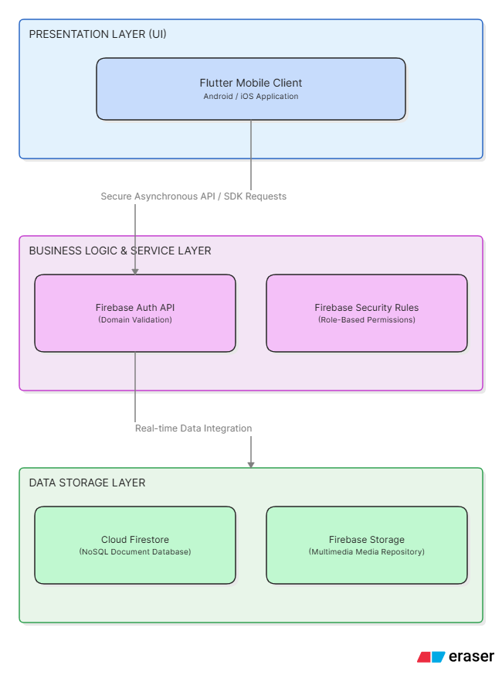

The business logic layer manages complaint routing, dynamic role-based access validation, and workflow state transitions, implementing Object-Oriented Design principles to promote code reusability, asynchronous thread processing, and high maintainability. The data layer utilizes a secure, cloud-hosted NoSQL document database alongside structured object storage to persist transaction logs and media attachments, ensuring data integrity, minimal query latency, and high confidentiality. Native integration with managed authentication services enhances structural verification and platform security.

Overall, this architectural design aims to provide a flexible, responsive, and secure foundation for the IUB CMS, aligning with modern mobile software engineering and cloud-native architectural best practices.

1.2 Process Flow / Representation
The process flow of the IUB Complaint Management System (CMS) is designed to efficiently handle the registration, multi-state routing, structural storage, and accessibility of grievance data within the university infrastructure.
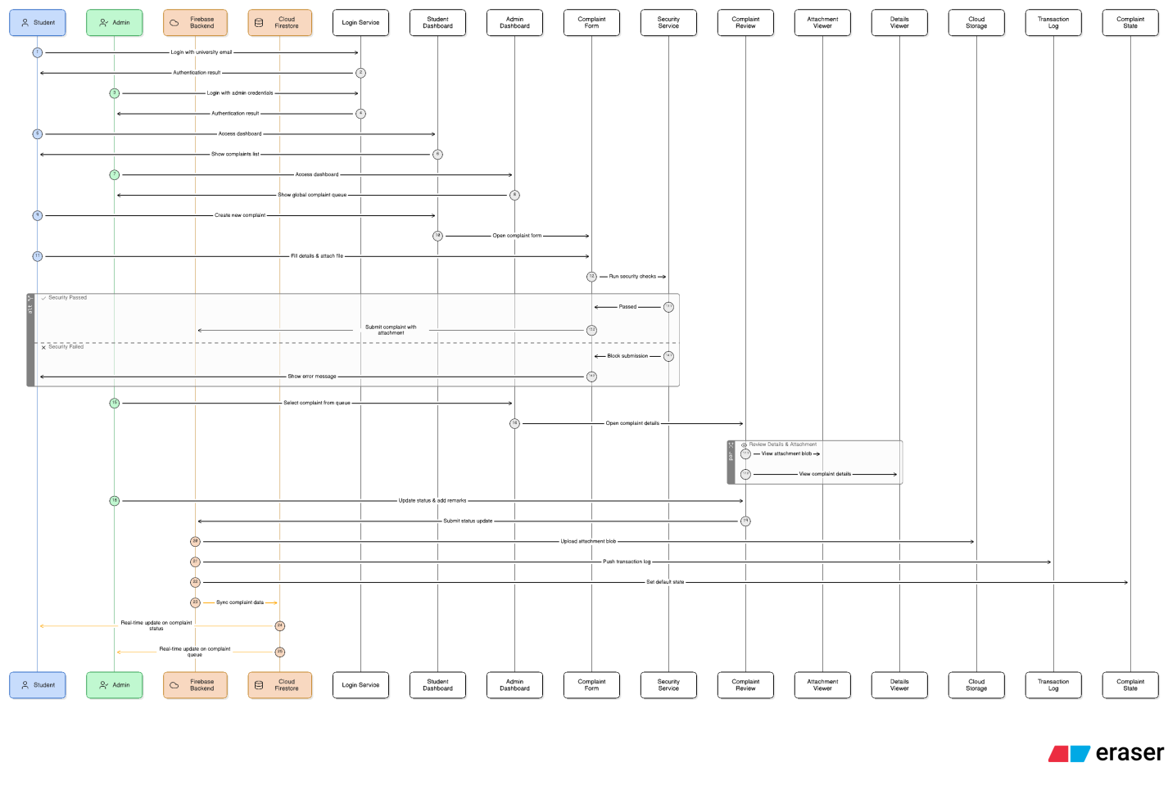
The process begins with the submission of a digital complaint, where authenticated student users input localized metadata, operational categories, textual descriptions, and optional multimedia payloads directly into the system. The application then processes this incoming transactional record dynamically through authentication checking and structural authorization rules, adhering to the principles of Object-Oriented Design and asynchronous database integration, to ensure immediate real-time synchronization, complete transparency, and system-wide data integrity.
1.3 Design Models
The applicable design models used to conceptualize, visualize, and map the object-oriented structure and transactional behaviors of the IUB Complaint Management System (CMS) include the following:

Class Diagram: This model illustrates the static structure of the mobile application by detailing the software's classes, attributes, operations, and the explicit object-oriented relationships (such as inheritance, association, and dependency) between entity objects like Users, Complaints, and History Logs.
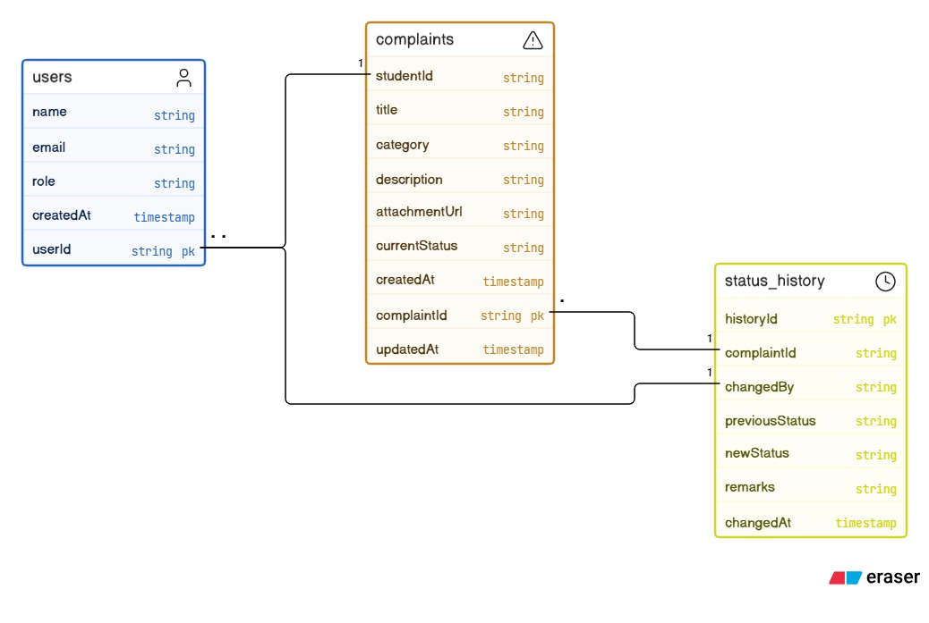

Sequence Diagram: This behavioral model represents the chronological interaction loops and message-passing sequences between frontend UI views, middleware validation controls, and backend cloud databases for critical operations like account verification, grievance submission, and administrative state updates.
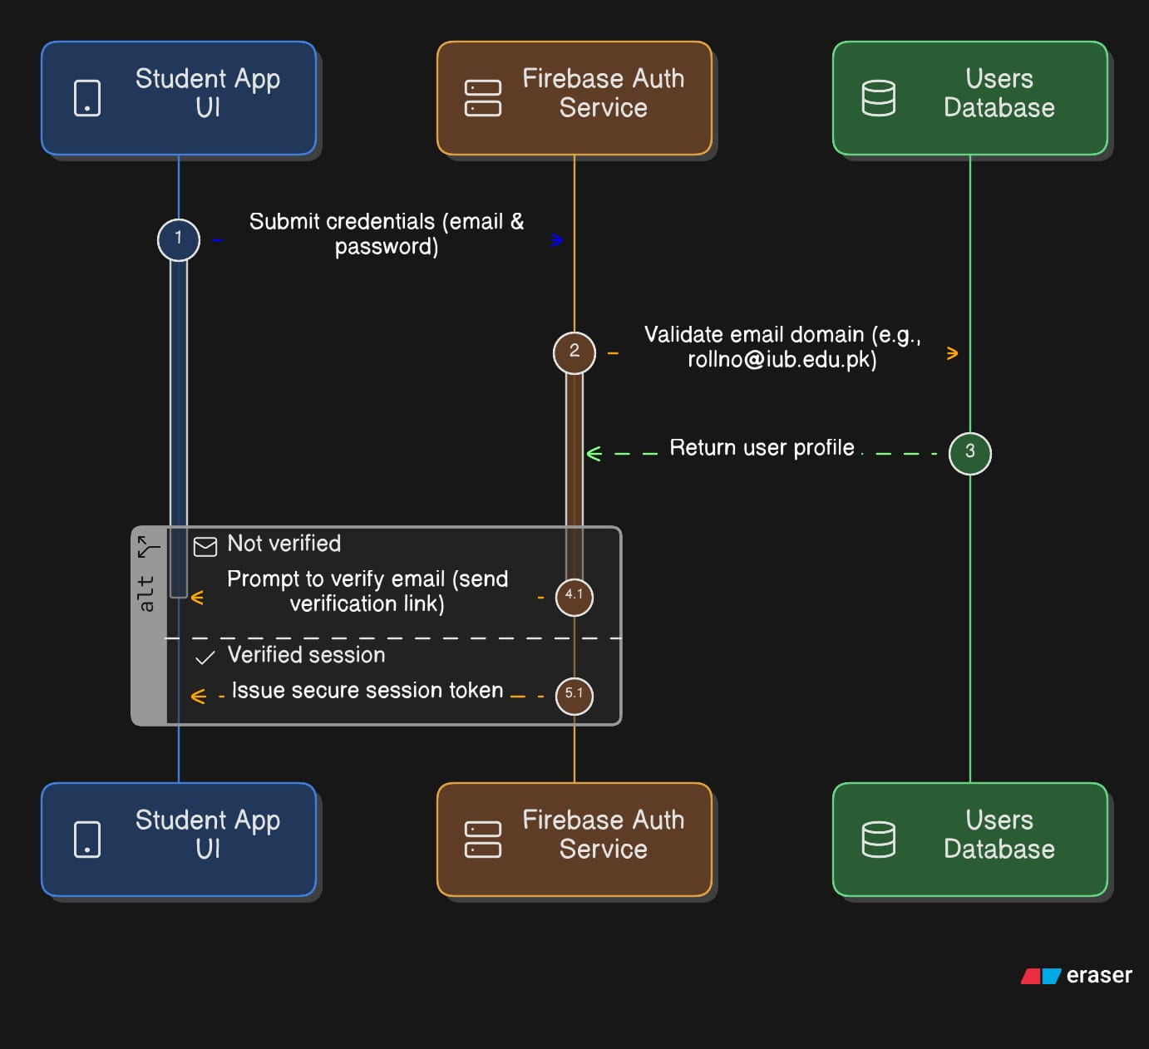

State Transition Diagram: This model maps the operational lifecycle and dynamic state machine transitions of an individual grievance, detailing how a data document shifts between status strings (Pending, In Progress, Resolved, and Rejected) based on administrative triggers and input actions.
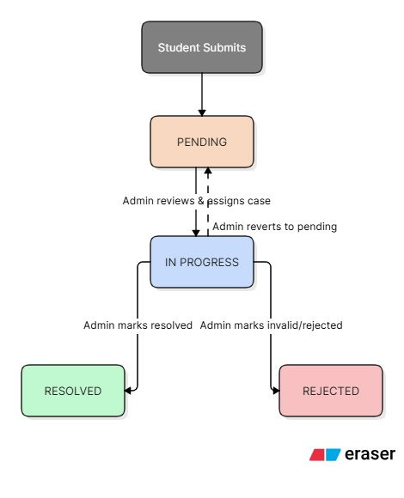

Data Flow Diagram (DFD): This diagram provides a structural representation of information flow through the system, capturing how raw user inputs map from the mobile UI screens, transition through Firebase execution services, and write permanently to cloud Firestore data storage collections.
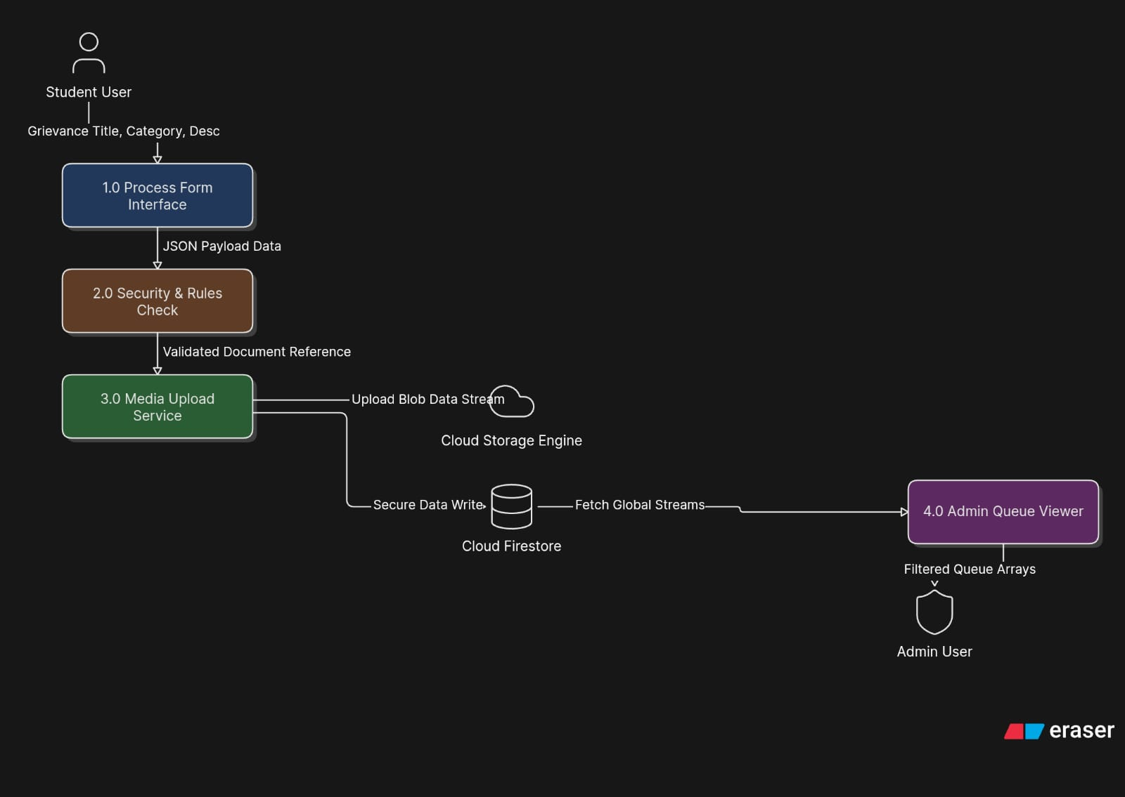

Schematic Diagram (Hardware Projects Only)
The IUB Complaint Management System (CMS) is engineered completely as a software-centric mobile solution deployed across Android and iOS environments, utilizing cloud-hosted microservices for database persistence and access authentication. No custom hardware infrastructure, microcontroller interfaces, or physical circuit boards are built or utilized for this system.
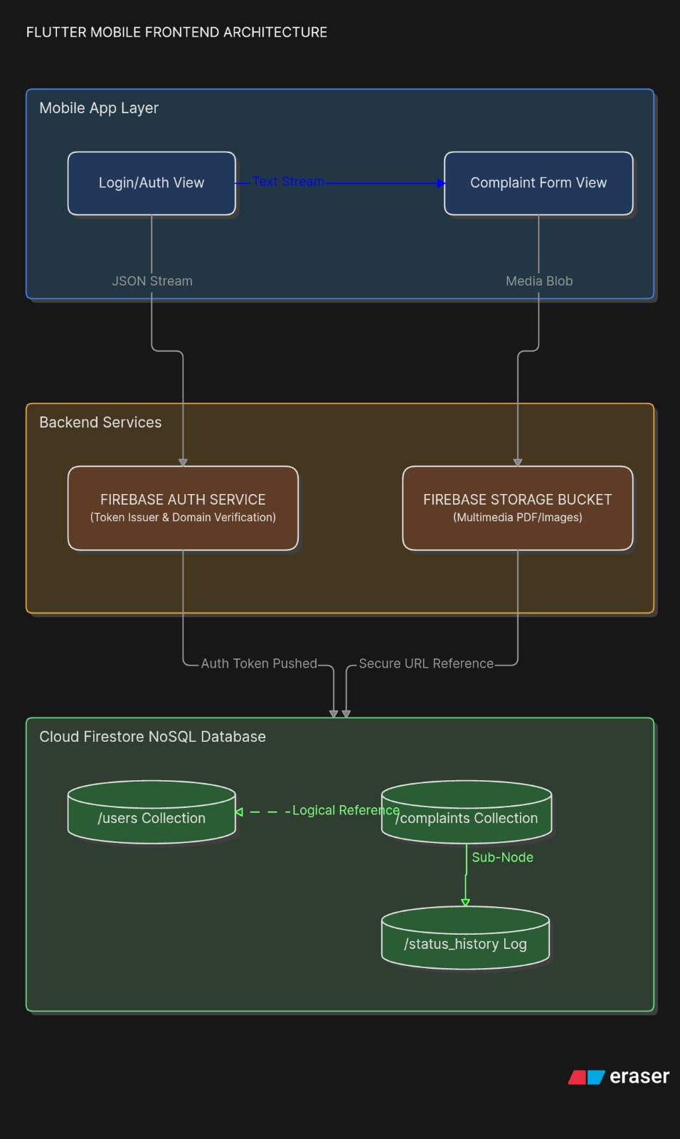
Consequently, schematic diagrams detailing physical wire paths, power loops, or electronic configurations using standard electrical symbols (such as resistors, capacitors, and microcontrollers) are Not Applicable (N/A) for this project design specification.

Timing Diagram (Hardware Projects Only)
A timing diagram is traditionally used to map synchronous physical clock signals, bus state transitions, or high-frequency communication latencies between electronic components. Because the IUB Complaint Management System is exclusively a software application, tracking real-time logic flows is instead structurally represented through higher-level behavioural software models like the System Sequence Diagrams (found in Section 6).

Therefore, low-level microelectronic waveform analysis and signal timing relationship constraints are Not Applicable (N/A) for this design framework.

- Data Model Schema
The data model of the IUB Complaint Management System (CMS) is designed to efficiently store, manage, and process grievance tracking data including users, complaints, status logs, and cloud storage pointers. The system follows a structured NoSQL document-based architecture where entities are interconnected through logical references to ensure data integrity, real-time consistency, and mobile scalability.

2.1 User Entity (RBAC – Role-Based Access Control)
The User entity manages system authentication profile records and role-based access control for different actors interacting with the platform, specifically differentiating between students and authorized university administrators.

Attributes:

UserID (Primary Key / Document ID)

Name

Email

Role (Student / Admin)

CreatedAt

Working Properties:

The User entity is responsible for system security, profile management, and authentication. It ensures that only authorized accounts can access the application. For the Student role, strict domain verification is enforced (rollno@iub.edu.pk). Role-based access control (RBAC) restricts or allows data writes depending on the user type; for instance, only users with the "Admin" role can alter system statuses, while "Student" roles are restricted to creating and modifying their own records.

Relationships:

User (1) → (M) Complaint (One student user can file and track multiple complaints).

User (1) → (M) StatusHistory (One admin user can make multiple status transitions and record corresponding log updates).

2.2 Complaint Entity
The Complaint entity is the core transactional entity of the IUB CMS, responsible for storing detailed grievance records filed by students, identifying the nature of the issue, and maintaining its current active lifecycle state.

Attributes:

ComplaintID (Primary Key / Document ID)

StudentID (Foreign Key / Reference Key)

Title

Category (Examination / Transport / Fee / IT Dept)

Description

AttachmentURL (Nullable / Optional)

CurrentStatus (Pending / In Progress / Resolved / Rejected)

CreatedAt

UpdatedAt

Working Properties:

The Complaint entity captures individual student grievances and acts as the primary data point for tracking workflow updates. Upon creation, the entity automatically assigns a default CurrentStatus value of "Pending". If a student uploads a supporting document or screenshot, the file is handled via secure media storage, and its string path is held within the AttachmentURL field. This entity supports full read/write operations for its respective author, allowing students to inspect, edit, or remove entries.

Relationships:

Complaint (M) → (1) User (Multiple complaint records map back to a single unique Student User).

Complaint (1) → (M) StatusHistory (One individual complaint generates multiple tracking states over time).

2.3 Status History Entity
The Status History entity operates as a transaction log tracking system, responsible for keeping a fully auditable timeline of lifecycle transitions, administrative decisions, and chronological feedback edits made regarding an active complaint.

Attributes:

HistoryID (Primary Key / Document ID)

ComplaintID (Foreign Key / Reference Key)

ChangedBy (Foreign Key / Reference Key)

PreviousStatus

NewStatus

Remarks (Nullable / Optional)

ChangedAt

Working Properties:

The Status History entity serves as an unalterable audit trail fulfilling administrative transparency standards. Every single time a university administrator alters the processing state of a grievance, a separate instance of this entity is instantiated. It references the parent grievance via the ComplaintID and logs the administrator via ChangedBy. It preserves snapshots of data shifts along with clear textual Remarks explaining the administrative action or final resolution description.

Relationships:

StatusHistory (M) → (1) Complaint (Many status log entries map down to one specific tracking complaint).

StatusHistory (M) → (1) User (Many lifecycle entries identify a single Admin User who authorized the state update).

2.4 System Configuration Entity
The System Configuration entity stores system-level parameters, operational variables, and dynamic drop-down choices that govern application-wide logic without hardcoded interference.

Attributes:

ConfigID (Primary Key / Document ID)

Parameter

Value

Working Properties:

This entity manages global constants across the system, such as defining active administrative categories (e.g., managing the list of valid departments like Examination, Transport, Fee, IT Department) or setting file upload limitations. It permits administrative modules to dynamically modify systemic features or validation limits directly inside the running software instance without demanding source code changes or recompilations.

Relationships:

Independent Entity

Accessed globally by the mobile clients during structural validation and category populating routines.

2.5 Overall Relationship Summary
The IUB Complaint Management System data model follows these main structural relationships:

User (1) → (M) Complaint

Complaint (M) → (1) User

Complaint (1) → (M) StatusHistory

StatusHistory (M) → (1) Complaint

StatusHistory (M) → (1) User (Tracks Admin associations)

User boundaries govern read, write, and patch permissions across all entities through Role-Based Access Control (RBAC).

System Configuration operates independently but manages system-wide parameter rules.

ER Diagram
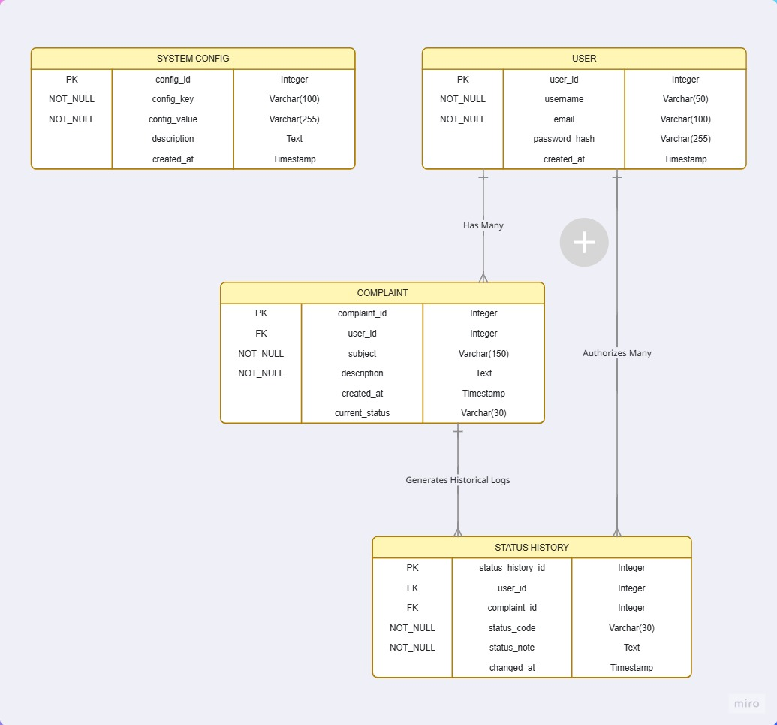

- User Interface
This sequence maps out the precise chronological order in which a user encounters each screen within the application ecosystem, defining the states and transaction routes.
Detailed Screen Sequence Specification

Step : Student Dashboard / Home Hub (Your First Screen)
Execution Interval: Acts as the default application landing screen upon successful authentication routing.

Functional Logic: Serves as an analytical summary dashboard layout. It displays active semester context parameters (Academic Year 2024 - Fall) and tracks cumulative transactional metrics categorized into dynamic data presentation tiles: 12 Total Filings, 08 Completed, and 04 Pending.
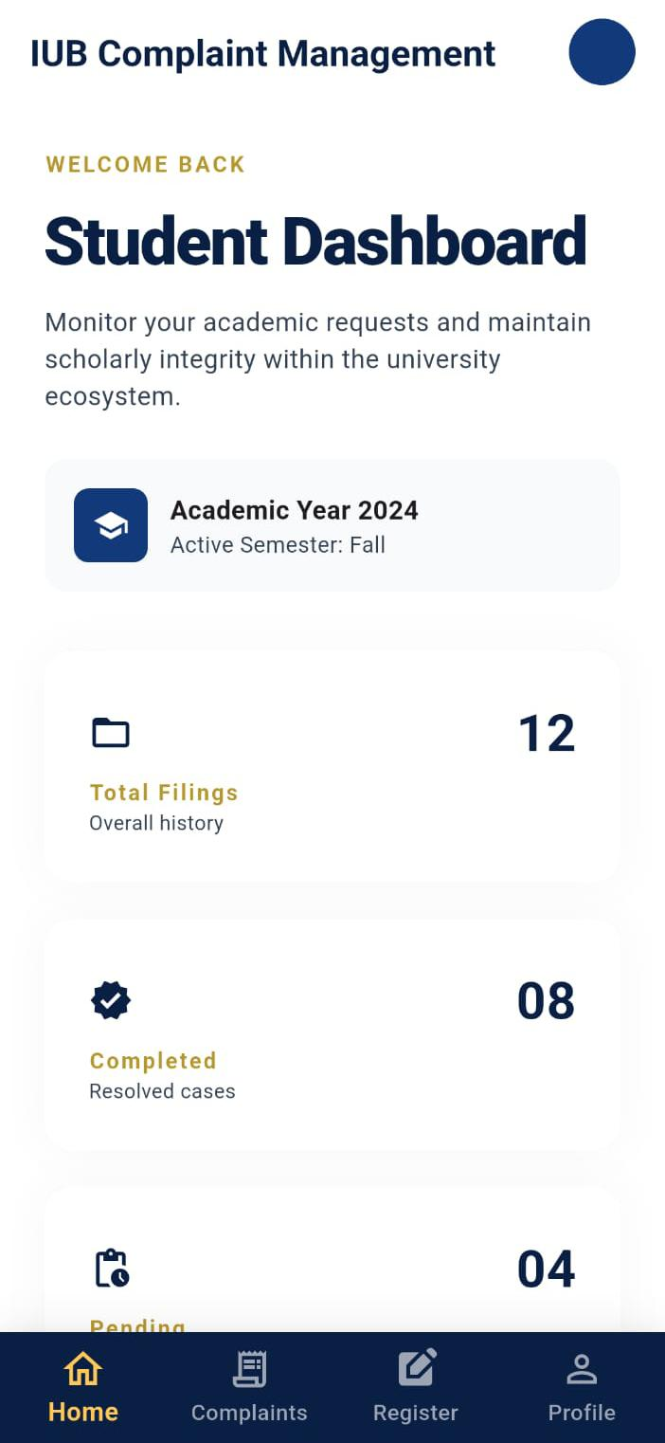

Formal Complaint Registration
Execution Interval: Triggers dynamically when the user selects the "Register" item from the persistent baseline navigation bar.

Functional Logic: This is the primary transactional input workspace. It collects three core variables: target department values from a bounded selection drop-down block, a concise subject line string controller, and a rich-text description area running a validation gate forcing a constraint of MIN 150 CHARS before allowing submission pipelines to fire.
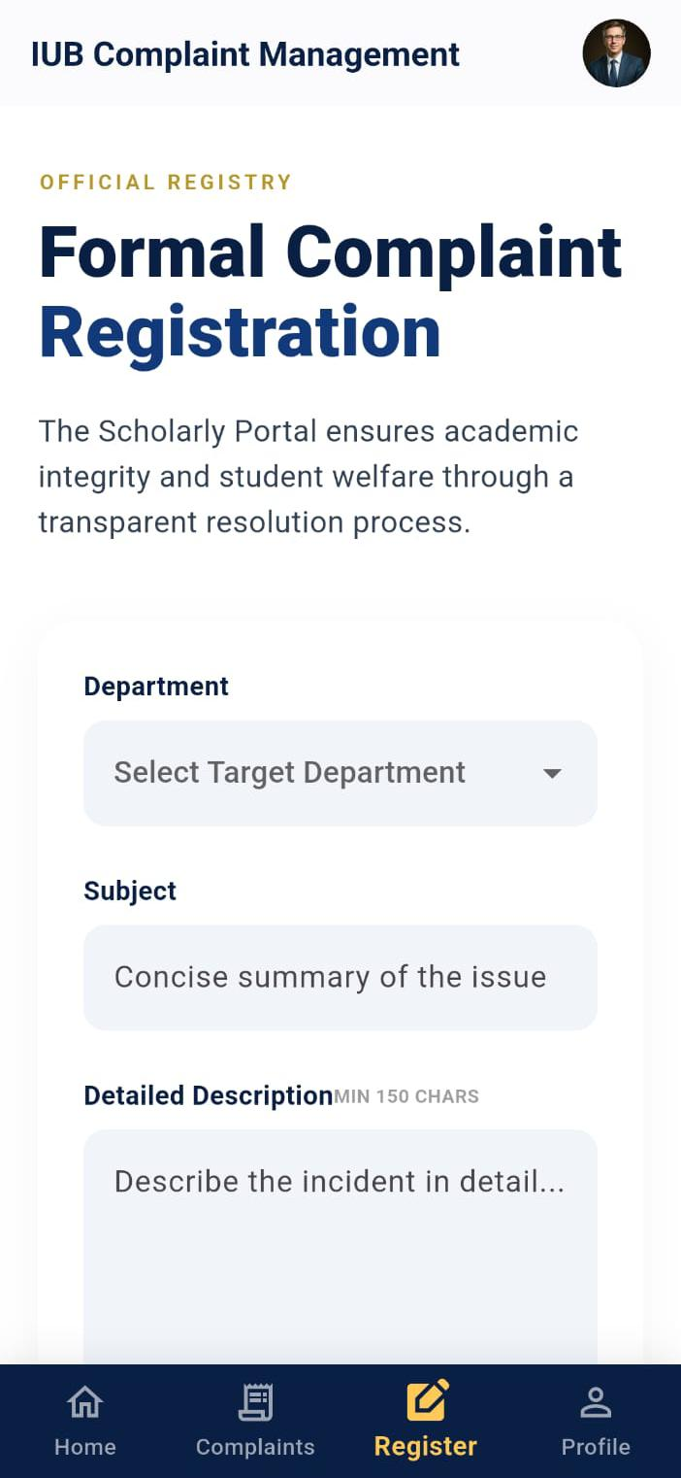
My Complaints Queue Tracker
Execution Interval: Mounts to the widget view array when the user taps the "Complaints" navigational node.

Functional Logic: Provides a real-time responsive stream tracking filed grievances. Each card lists data fields including custom tokenized IDs (e.g., IUB-2023-0842), categories, dates, and conditional state indicator tags (Pending rendered in amber background text, In-Progress wrapped in a distinct deep navy capsule). It features an integrated substring search engine.
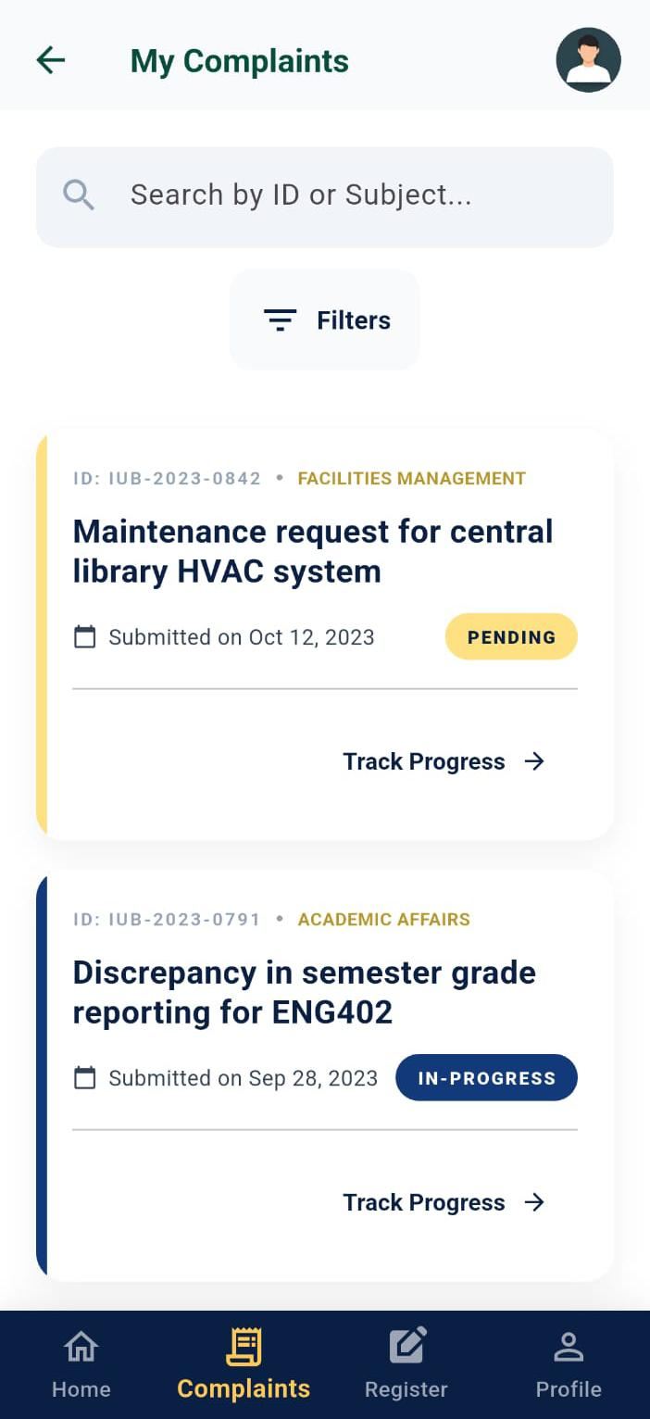
My Profile Screen
Execution Interval: Pushed onto the screen view context when tapping the "Profile" action icon.

Functional Logic: Renders verified systemic information verifying institutional standing (Alexander J. Sterling, Senior Undergraduate, Student ID: 20-43512-1). It handles secure session clear instructions by deploying the Sign Out cache clearing methods, routing the app context back to Step 2.


